
MEMORANDUM

To: | Charlie Refvem, Department of Mechanical Engineering, Cal Poly SLO crefvem@calpoly.edu
From: | Colby Cordoba ccordoba@calpoly.edu  Hobbs Hegedus hhegedus@calpoly.edu
Date: | 2-22-2026
RE: | Lab 0x05 - Line Following

Assignment
In Lab 0x05, the goal is to create a new hardware driver for the Romi line sensors and use that sensor feedback to make Romi drive reliably around a ~60 cm diameter circle using closed-loop control.
A recommended approach is to do the work in two stages: first, design/test a sensor driver that produces “usable” line data (often including calibration and a processed value like a centroid error), then integrate it into the existing Lab 0x04 control framework.
For control, the lab suggests a cascaded structure: use an outer-loop line-follow PI/PID to compute a steering correction that adds to one wheel’s speed setpoint and subtracts from the other wheel’s setpoint, while the inner-loop wheel-speed PID tracks those wheel setpoints.
First lets describe our previous lab 0x04 control framework and coincident tasks
- motor_driver.py: Low level motor actuation
  - This class takes the DRV8838 interface and sets direction for GPIO pins, and PWM duty cycles along with using sleep pins to enable disable driver where effort is saturated to 100%.
  - Each encoder class uses a hardware timer in encoders to track wraparound. Each update computes delta counts and dt in microseconds and then converts to couns/s
- task_control_loop.py: Inner-loop PI(D) control that outputs “effort”
  - The task_control_loop object implements PI with saturation
  - The task_control(...) generator is the actual scheduled task: it checks the enable flag, applies live updates of Kp and Ki, computes the effort, and writes it to the effort share.
- task_motor.py: Motor (FSM) that reads encoder, applies effort, and logs data
  - Updates encoder and publishes omega (counts/s) and position to shares.
  - Task_motor: Applies effort shares to motor driver when enabled and logs samples into queues until they are full where it then stops logging.
- task_user.py: Two UIs: tuning menu and data-collection menu
  - Tuning UI: used when start_user == 0 and used to edit Kp/Ki/setpoint and then switch to data collection.
  - Data-collection UI: used when start_user == 1. It supports l, r, or b to collect samples, waits for the queues to fill, then prints CSV-like data for plotting.
Now this program was very tricky and inefficient to work with but most importantly it had many signs and units issues which consistently caused problems during encoder and motor unit conversions. These issues caused the wheels to exhibit runaway or oscillation behavior. Additionally, to combat our issues we moved the closed loop PI controller inside the motor has this is mainly because a separate task means we must have the tasks stay in sink where the motor tasks update omega measured which is then ready by control tasks which writes effort and then writes to motor tasks. Another issue that we would have is our old controller tasks is it is easier to work with having a cleaner interface for outer loop line following where each motor has its own PI loop.
Now let's describe how our lab 0x05 works:
- motor_driver.py: low-level motor actuation
  - set_effort(effort) saturates to ±100, sets direction pin, then sets PWM duty percent.
  - enable() brings nSLP high (awake), disable() puts it to sleep.
- encoder.py: wheel sensing (position + velocity)
  - Uses a hardware timer in encoder mode (ENC_AB), and supports invert = to flip sign convention.
  - update() computes dt_us, reads the timer count, corrects wraparound, accumulates position.
  - get_velocity() returns counts/s using delta * 1e6 / dt_us (and applies sign if needed).
- sensor_driver.py: QTR analog line sensor (normalized + centroid)
  - QTRSensorsAnalog: Reads raw ADC (0…4095) and normalizes each channel to 0…1000 based on white/black calibration.
  - Provides centroid-style “Pololu units” position: 0…(N−1)*1000, and line_error() as signed error from center.
- task_read_line(): (defined in main.py) reads normalized sensor values and computes line_err via weighted centroid when signal is strong enough; sets line_ok accordingly.
  - If cal_cmd==1
    - Calibrate white;
  - If cal_cmd==2
    - Calibrate black, then set cal_done=1.
  - If later time permit will restructure for a cleaner main.
- task_motor.py: The wheel task (sensor + controller + actuator + logging)
  - Every cycle (when enabled):
    - Update encoder and publish omega and position shares.
    - Compute effort: If internal PI enabled: reads ref = setpoint.get() (counts/s), runs PI, and writes the computed effort back into the effort share (so the UI can still display it).
    - Apply effort to the motor driver.
    - Log (omega, t_us) into the queues until full; when full it stops logging only.
- task_follow_line.py: Outer-loop steering PI
  - When follow_en==0: it forces symmetric setpoints (spL=spR=v_nom) and publishes dv=0.
  - When follow_en==1:
  - Otherwise it computes:
    - integrate error: dv = kp*err + ki*i_term
    - saturates dv and does simple anti-windup
    - clamps final spL/spR to limits
- task_user.py — two UIs (tuning vs data collection)’
  - Data UI (start_user==1)
    - l/r/b starts collection, waits for queues to fill, then prints CSV rows.
    - x stops motors during collection.
  - Tuning UI (start_user==0)
    - Lets you set wheel gains, v_nom, line gains, calibration, stream status, and (important) includes:
      - n = run motors (live test, no logging/printing)
      - x = stop motors
To help understand how our code functions, here is Table 1, which features all of our shared variables and their purposes.

Table 1: Table of Shares and Queues

Kind | Name | Type/Len | Written by | Read by | Meaning / Units | Notes / Aliases
Share | motorLGo | B | Task_User; Task_Tuning_UI | Task_Motor_L | Motor enable/go flag (left). 1=run,0=stop | Param aliases: enable / leftMotorGo
Share | motorRGo | B | Task_User; Task_Tuning_UI | Task_Motor_R | Motor enable/go flag (right). 1=run,0=stop | Param aliases: enable / rightMotorGo
Share | Kp | f | Task_Tuning_UI | Task_Motor_L; Task_Motor_R; Task_User (display) | Wheel PI proportional gain (inner loop) | One shared pair for BOTH motors
Share | Ki | f | Task_Tuning_UI | Task_Motor_L; Task_Motor_R; Task_User (display) | Wheel PI integral gain (inner loop) | One shared pair for BOTH motors
Share | setpointL | f | Task_Follow_Line | Task_Motor_L | Left wheel velocity setpoint (counts/s) | Alias in follow: spL
Share | setpointR | f | Task_Follow_Line | Task_Motor_R | Right wheel velocity setpoint (counts/s) | Alias in follow: spR
Share | omegaL | f | Task_Motor_L | (none in this build) | Measured left wheel speed (counts/s) | Output from encoder; available for debug
Kind | Name | Type/Len | Written by | Read by | Meaning / Units | Notes / Aliases
Share | omegaR | f | Task_Motor_R | (none in this build) | Measured right wheel speed (counts/s) | Output from encoder; available for debug
Share | posL | l | Task_Motor_L | (none in this build) | Measured left wheel position (counts) | Encoder position; available for debug
Share | posR | l | Task_Motor_R | (none in this build) | Measured right wheel position (counts) | Encoder position; available for debug
Share | effortL | h | Task_Motor_L (internal PI) | (none in this build) | Left motor effort command (±100 sat) | In external mode this would be an INPUT
Share | effortR | h | Task_Motor_R (internal PI) | (none in this build) | Right motor effort command (±100 sat) | In external mode this would be an INPUT
Share | start_user | B | Task_Tuning_UI; Task_User | Task_Tuning_UI; Task_User | UI mode select: 0=tuning UI, 1=data UI | Both read + write (handshake)
Share | follow_en | B | Task_Tuning_UI | Task_Follow_Line; Task_User (display); Task_Tuning_UI (status) | Enable outer line-follow loop | Alias in follow: enable_follow
Share | v_nom | f | Task_Tuning_UI | Task_Follow_Line; Task_User (display) | Nominal forward speed command (counts/s) | Passed into UIs as param name setpoint
Kind | Name | Type/Len | Written by | Read by | Meaning / Units | Notes / Aliases
Share | Kp_line | f | Task_Tuning_UI | Task_Follow_Line; Task_User (display); Task_Tuning_UI (status) | Line-follow proportional gain (outer loop) | Do NOT connect to task_motor
Share | Ki_line | f | Task_Tuning_UI | Task_Follow_Line; Task_User (display); Task_Tuning_UI (status) | Line-follow integral gain (outer loop) | Do NOT connect to task_motor
Share | line_err | f | Task_Read_Lines | Task_Follow_Line; Task_User (display); Task_Tuning_UI (status) | Line position error (QTR units, ~±3500) | Computed from normalized sensor centroid
Share | dv_out | f | Task_Follow_Line | Task_User (display); Task_Tuning_UI (status/stream) | Steering correction (dv) output from outer loop | Debug/status share
Share | line_ok | B | Task_Read_Lines | Task_Follow_Line | Line validity flag (1=line detected) | Used to gate/reset controller when lost
Share | cal_cmd | B | Task_Tuning_UI; Task_Read_Lines (clears) | Task_Read_Lines | Calibration command: 0=idle,1=white,2=black | Sensor task resets to 0 after handling
Kind | Name | Type/Len | Written by | Read by | Meaning / Units | Notes / Aliases
Share | cal_done | B | Task_Read_Lines | Task_Tuning_UI (then clears) | Calibration complete flag (sensor task sets 1) | UI clears back to 0
Share | log_en | B | main.py only | (none) | (unused in this build) intended log enable gate | Set to 1 then never referenced
Queue | dataValuesL | f[100] | Task_Motor_L | Task_User | Logged left wheel omega samples (counts/s) | Producer=Motor, Consumer=User
Queue | timeValuesL | L[100] | Task_Motor_L | Task_User | Logged left timestamps (microseconds since start) | Producer=Motor, Consumer=User
Queue | dataValuesR | f[100] | Task_Motor_R | Task_User | Logged right wheel omega samples (counts/s) | Producer=Motor, Consumer=User
Queue | timeValuesR | L[100] | Task_Motor_R | Task_User | Logged right timestamps (microseconds since start) | Producer=Motor, Consumer=User

Table 2: Task, Periods, and Priorities
Task Name (scheduler) | Task Object / Function | Priority | Period (ms) | What it does (1-line)
Left Motor | leftMotorTask.run | 1 | 20 | Updates left encoder, computes internal PI effort, drives motor, logs to L queues
Right Motor | rightMotorTask.run | 1 | 20 | Updates right encoder, computes internal PI effort, drives motor, logs to R queues
Line Read | task_read_line | 3 | 20 | Reads QTR sensors, computes line_err, sets line_ok, handles calibration via cal_cmd/cal_done
Line Follow | followTask.run | 3 | 20 | Outer PI loop: uses line_err to compute dv, writes setpointL/setpointR, publishes dv_out
Tuning UI | tuningTask.run | 0 | 50 | Command menu: sets gains, v_nom, toggles follow, calibration commands, live motor test
User (Data UI) | userTask.run | 0 | 50 | Data collection UI: starts/stops motors, prints queue data, shows headers/status

Figure 1 shows our task diagram to illustrate how our code is organized across multiple files. Figure 2 is a block diagram depicting the overall control structure of our program. Figure 3 contains multiple finite state machines for our individual task files.

Figure 1. Task Diagram
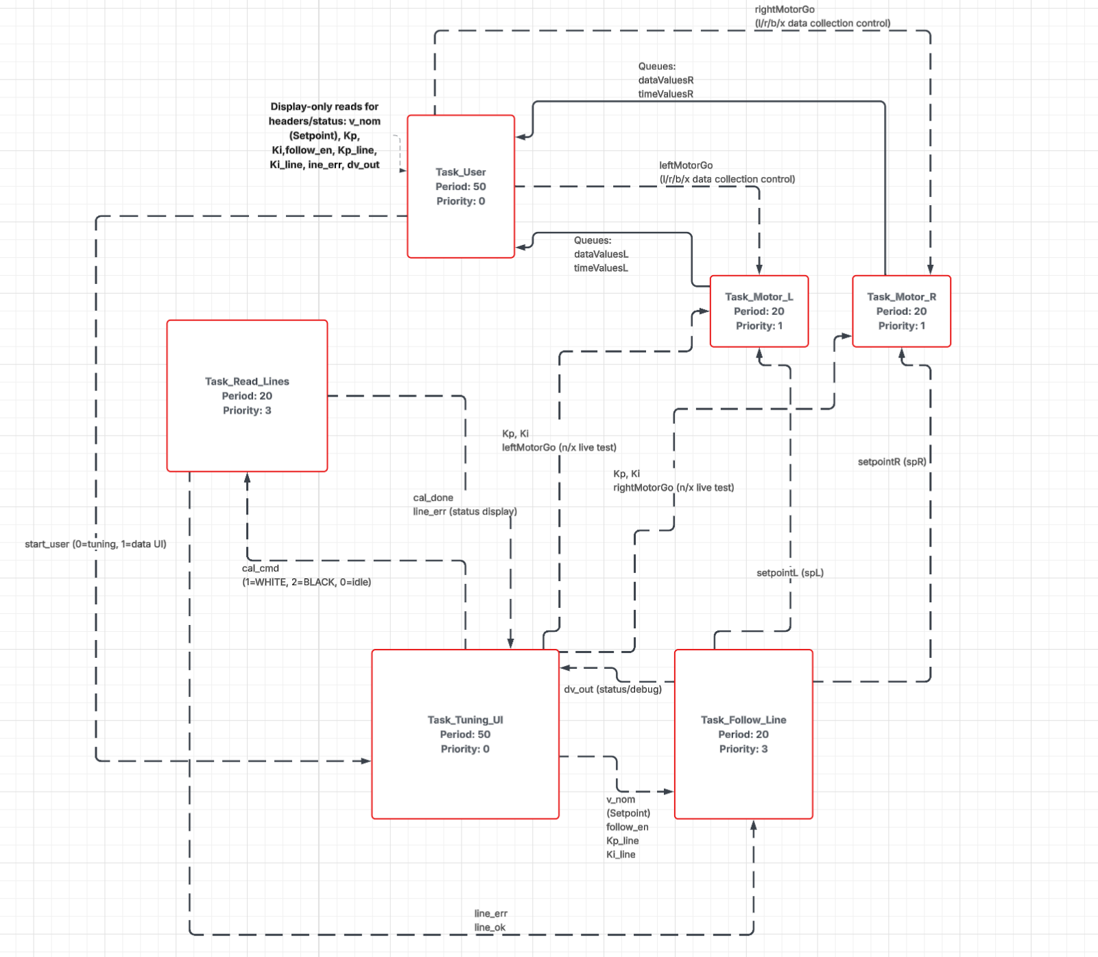

Figure 2. Box Diagram
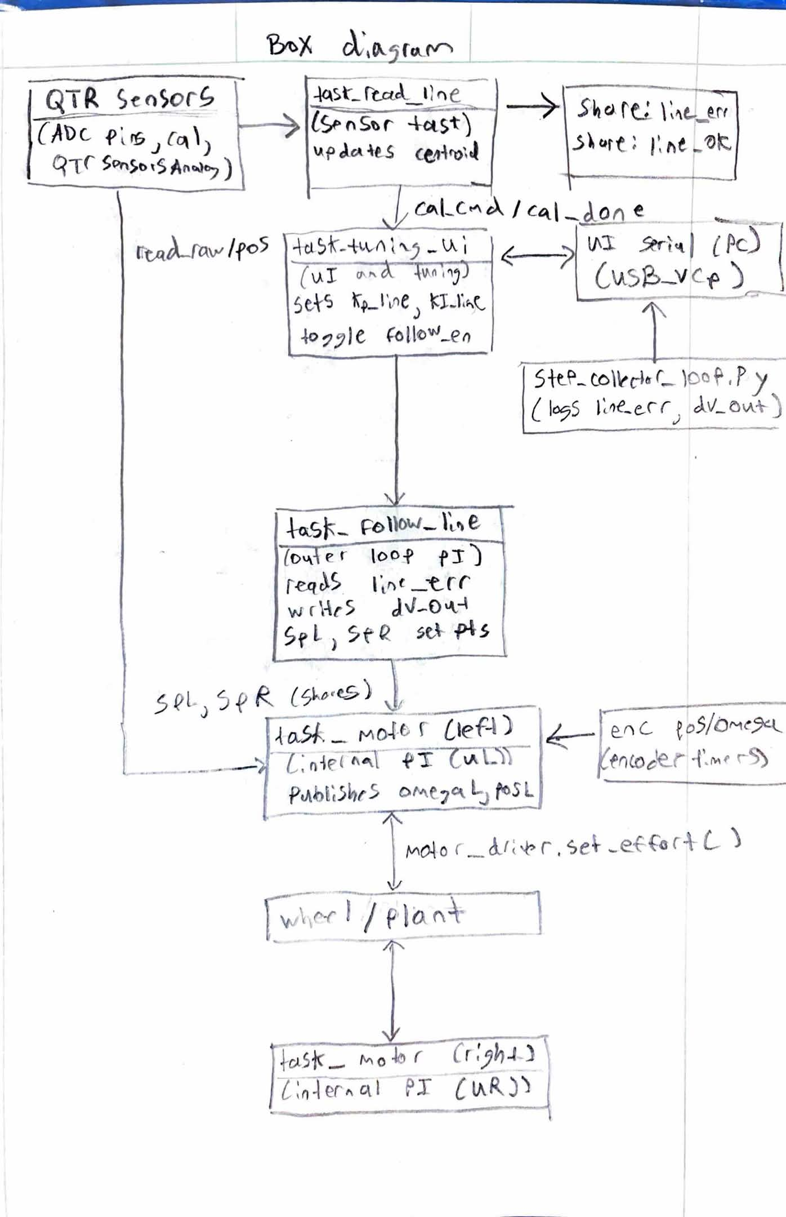
Figure 3. Finite State Machines
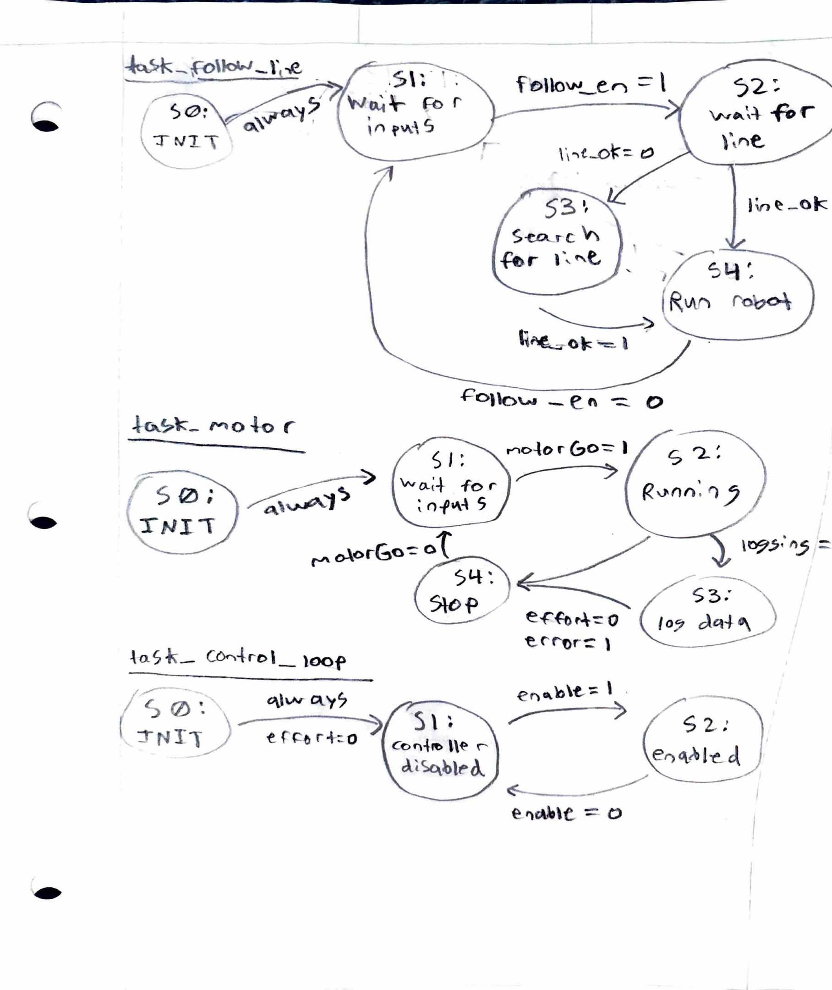
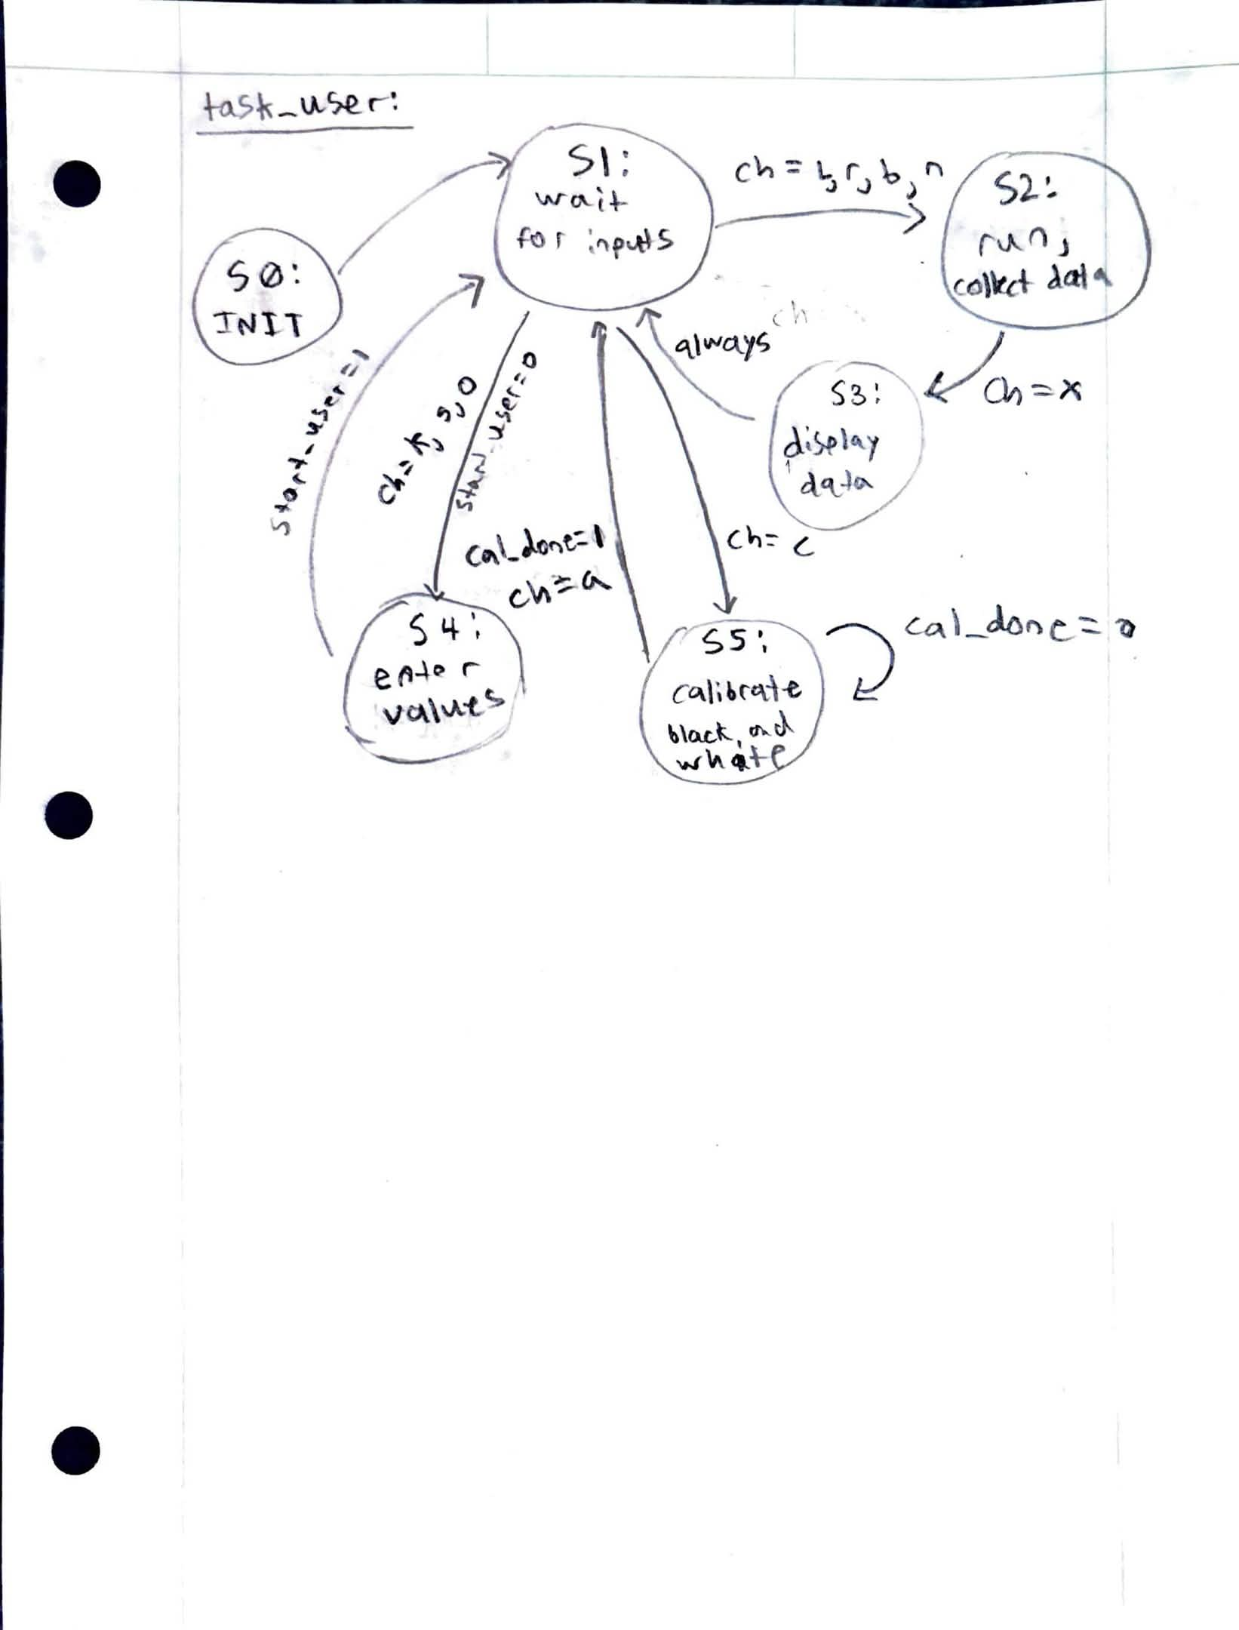
Figures 4 and 5 are our response plots produced by Step_collector_loop, which demonstrate improved performance as the line is followed.
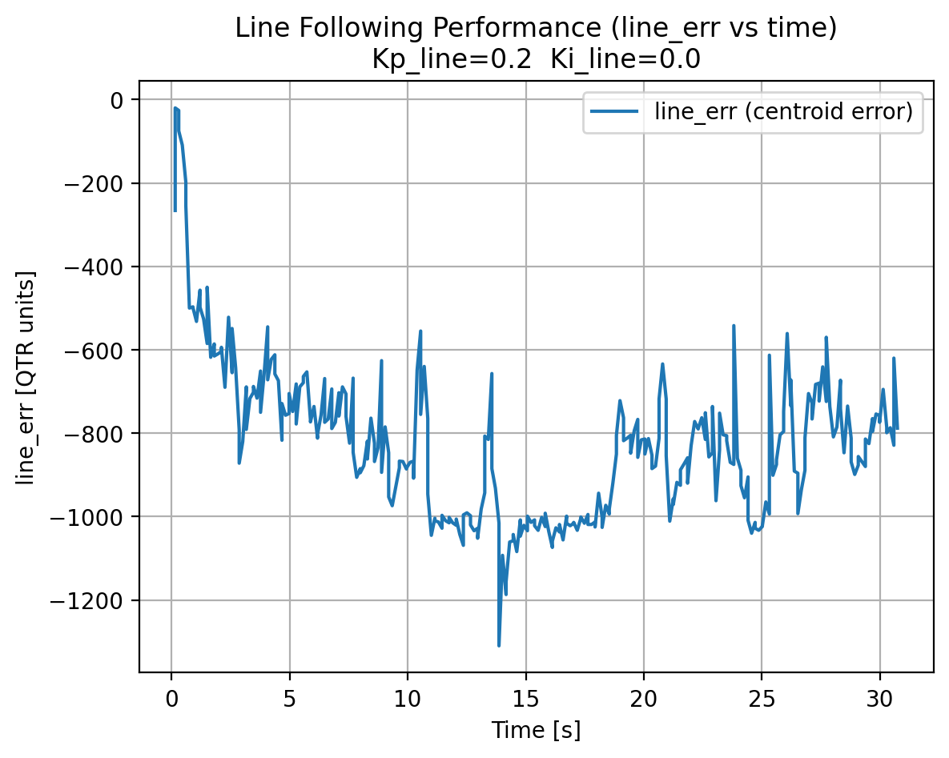
Figure 4. Line Error vs Time Plot

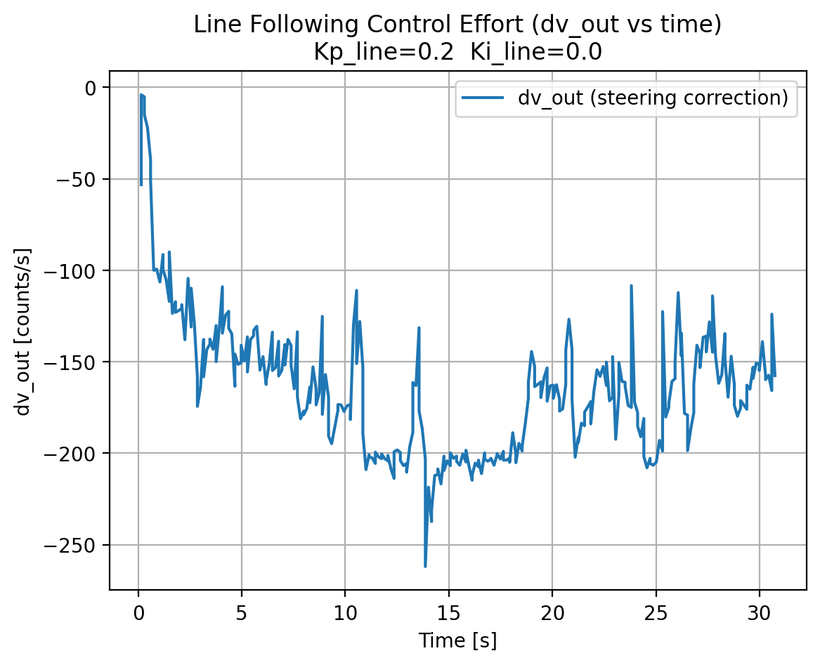
Figure 5. Dv Out vs Time Plot
To demonstrate the functionality of our code, below are screenshots of our new UI and screenshots of Putty showing the operation of UI.
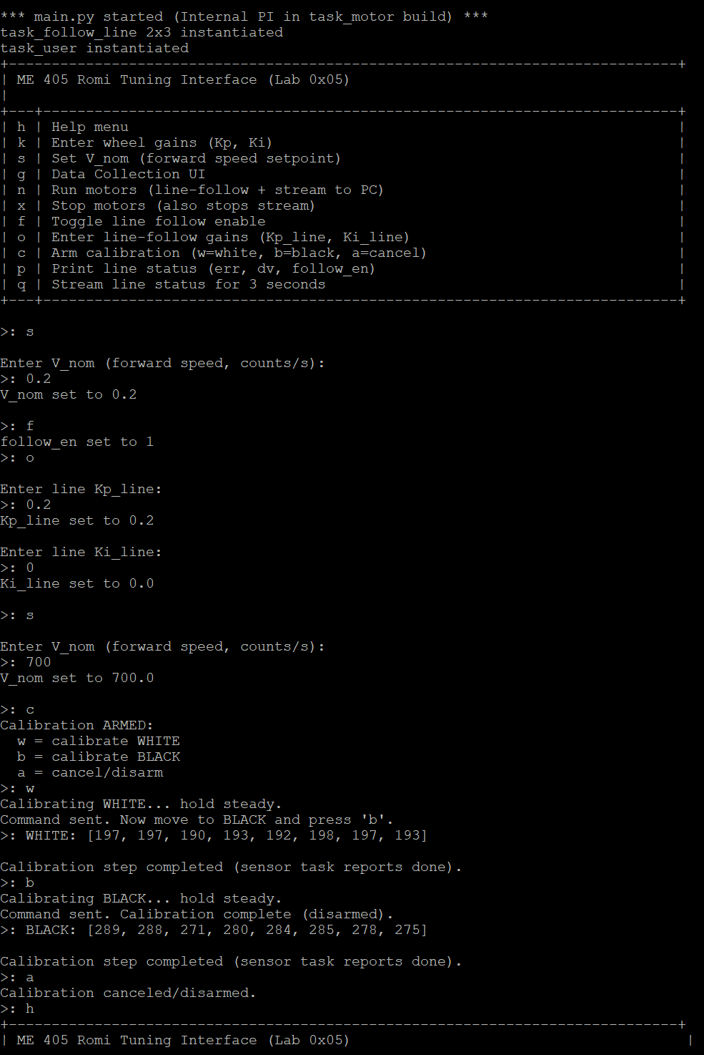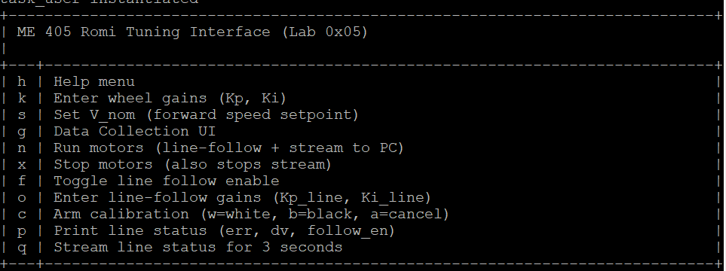
References:
Source Files:
- Cotask.py
- Encoder.py
- Main.py
- Motor_driver.py
- Sensor_driver.py
- Step_collector_loop.py
- Task_control_loop.py
- Task_follow_line.py
- Task_motor.py
- Task_share.py
- Task_user.py
- Ui_help.py

